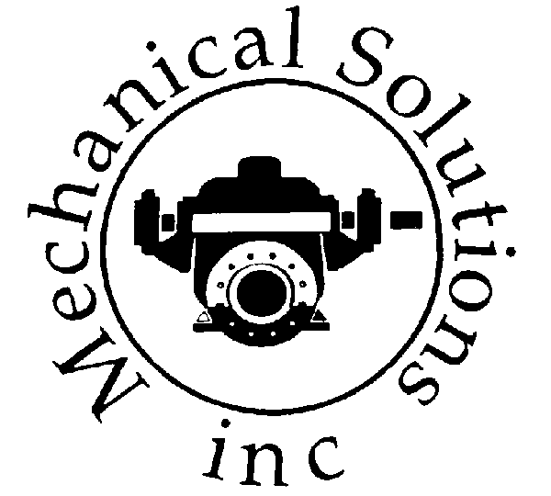Mechanical Solutions Inc.
121 Commerce Way | TEL: (860) 290-1564, X103
P.O. Box 790 | FAX: (860) 290-1825
South Windsor, CT 06074-0790 | www.msipump.com

“SBE - Small Business Enterprise” – CT Certified

Friday, July 31, 2026

Attention:
Reference:

Dear :

We propose to furnish the following equipment for your consideration:

Freight: FOB Factory, Freight Add to Site
Delivery:
Startup: Service is available for $95.00 per hour portal to portal if required.
Note: Cyclone Separators, Cuno Filters or Spare Parts if not called out in the description of the pumps and accessories are considered to be by others. Additional pricing for these items are available upon request.
Terms: Net 30 Days. There will be a 25% minimum restocking fee for all returned items. Mechanical Solutions Inc. is not responsible for liquidated damages.

Sincerely

Kenneth P. Reynolds
